Dear Big Windermere Survey volunteer,
We are aware of reports that a bloom of cyanobacteria (also known as blue-green algae) has developed on parts of Windermere. Therefore, it is also possible that similar blooms may have developed on other lakes and streams that are part of our Big Windermere Survey (BWS). Some types of cyanobacteria can produce toxic chemicals that may harm humans and animals. We are writing to you now to outline how this may impact our sample collection work and the steps you should follow to make sure you avoid any potential risks associated with cyanobacteria whilst you undertake sample collection on June 26th.

- At this stage, we will continue as planned with the BWS. The risk assessment and associated sampling protocol that underpins the BWS ensures any risk to volunteers associated with cyanobacteria is reduced to acceptable, very low levels. If this position changes and we need to alter the BWS then we will contact you again in advance of June 26th.

- If you arrive at your designated sample site and observe a dense surface scum that may be cyanobacteria (see example images below) then we ask you to:

  - If the scum is localised and you can move a short distance (up to a few 10s of metres) to access an area of the lake or river where the scum isn’t present, please do this and collect your sample from that new location.

  - If the scum is very extensive and/or moving to a new area of the lake shore or river bank is not possible, then we ask you not to complete a sample at that location. Instead, please take a picture of the surface scum, email this picture to windermere@fba.org.uk and bring your unused sample pack to the BWS science hub that you were originally assigned to.
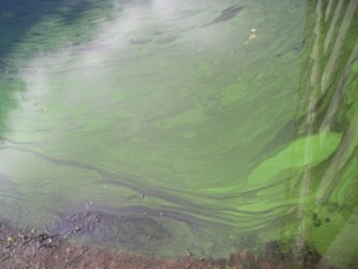
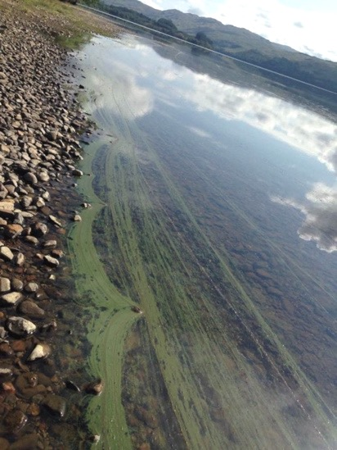
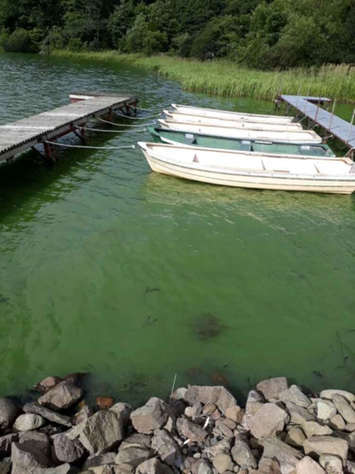

Images showing examples of cyanobacterial blooms, taken from the UKCEH Bloomin’ Algae website (https://www.ceh.ac.uk/our-science/projects/bloomin-algae). NB these images have not been taken from the bloom currently affecting parts of Windermere.

- Assuming that your site is not affected by a cyanobacterial bloom, or that you can move a short distance to avoid an area of the bloom, then you can continue with sampling as planned.

- As described in our training video (https://www.fba.org.uk/volunteer/windermere-big-lake-survey) and the risk assessment for the BWS, anyone who is involved in water sample collection must wear protective gloves on both hands whenever undertaking sampling work. This will ensure that you avoid any contact between potentially contaminated water and your skin.

- Make sure that you do not enter the water as part of the sample collection process. Use the sampling bucket attached to an extension pole or to a rope in order to collect a sample from the lake or stream and return it to the shore or bank for processing. We also recommend that you do not allow pets to enter the water when there is a potential risk of exposure to cyanobacteria.

- Take care when pouring sample from the collection bucket into sample bottles or centrifuge tubes, avoiding splashing water onto areas of your skin that are not covered by the protective gloves. Work carefully and slowly to avoid splashing.

- It should go without saying (!), but avoid ingesting or drinking any water from the lake or stream as part of your sampling work.

- When you’ve completed sample collection and placed all the sampling items back into your sample pack, please ensure you use the hand sanitizer supplied within the sampling packs.

- As soon as possible after sample collection, please ensure that you wash your hands thoroughly with soap and water.

If you have any questions about this information do feel free to contact us using windermere@fba.org.uk and we’ll be very happy to help.

Thanks again for volunteering to be part of The Big Windermere Survey!

